COORDINATES
Pearson Edexcel - Tuesday 19 May 2020 - Paper 1 (Non-Calculator) Foundation Tier

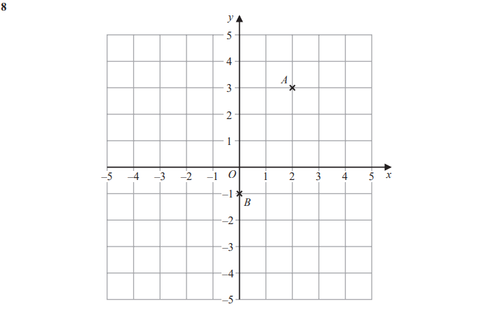
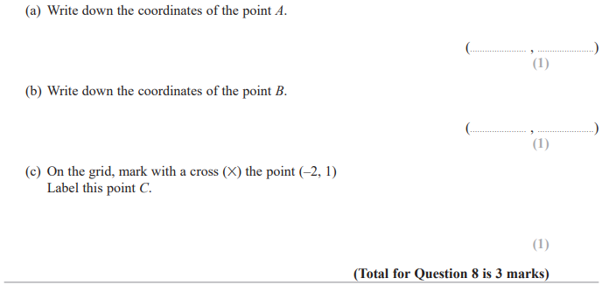

Pearson Edexcel - Tuesday 6 November 2018 - Paper 1 (Non-Calculator) Foundation Tier

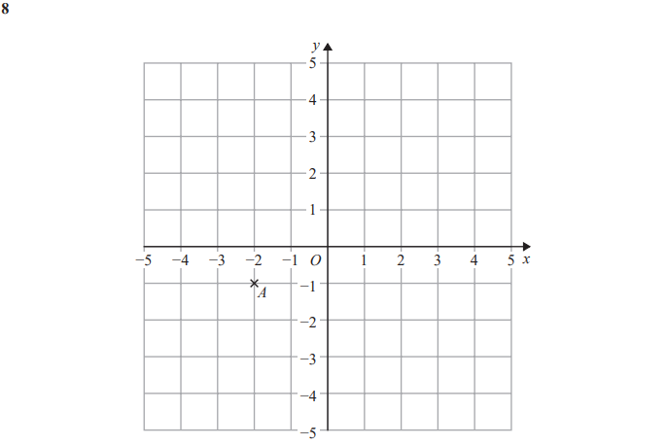
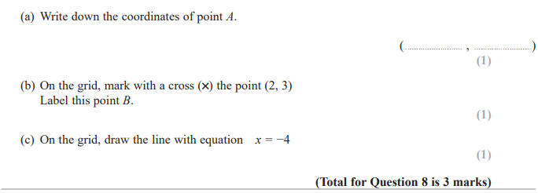

Pearson Edexcel - Thursday 2 November 2017 - Paper 1 (Non-Calculator) Foundation Tier

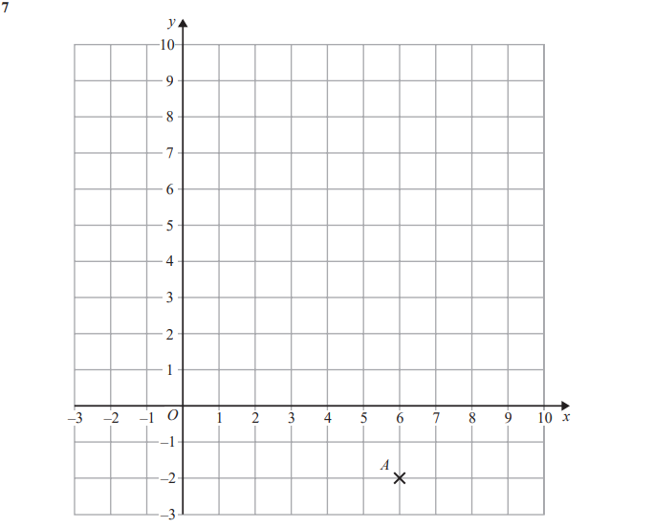
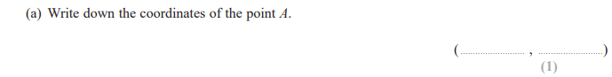
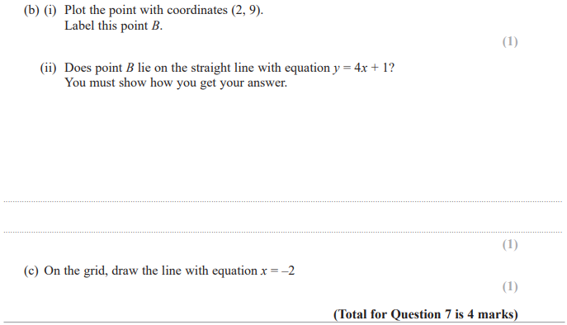

Pearson Edexcel – Specimen 2 - Paper 1 (Non-Calculator) Foundation Tier

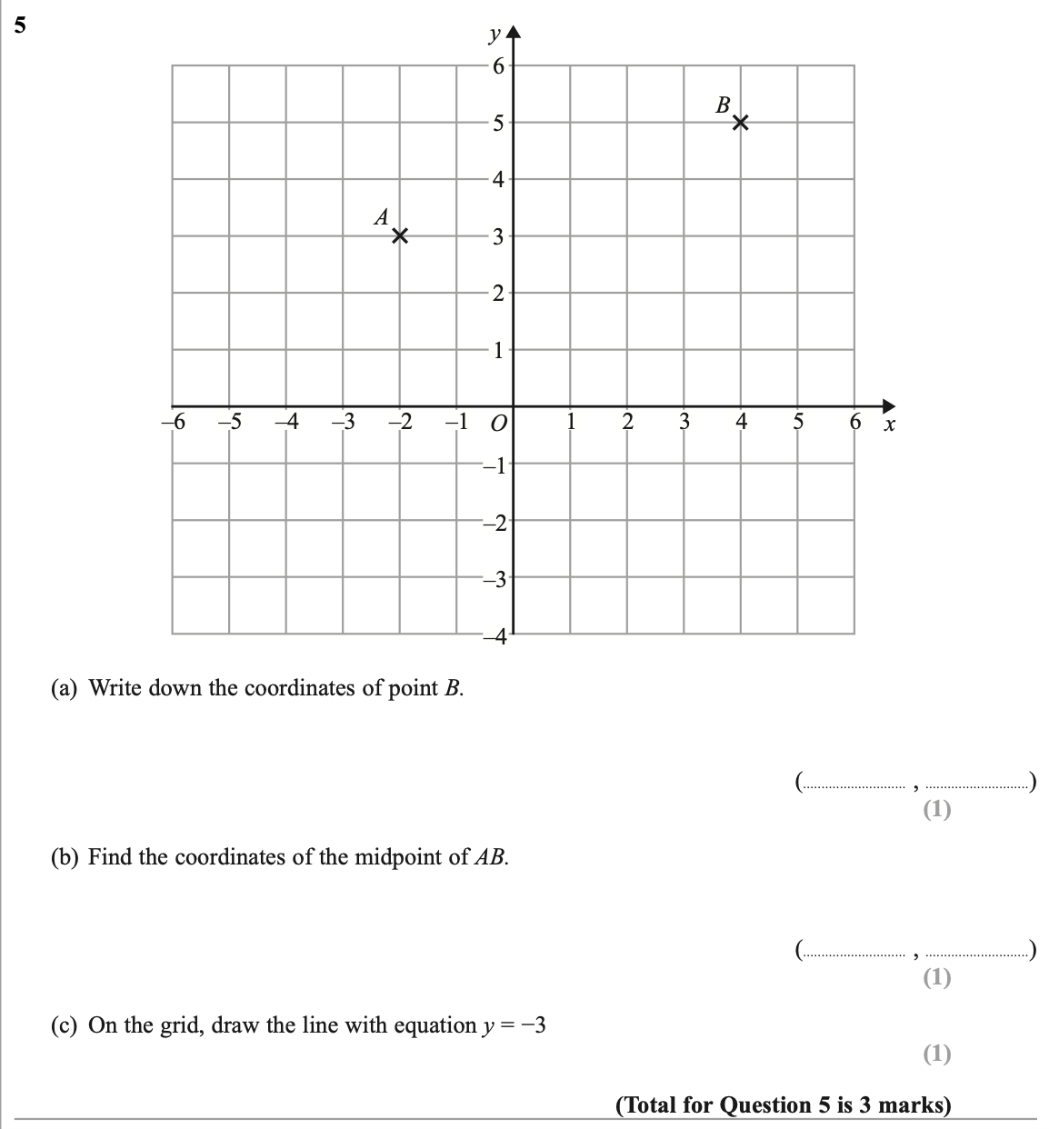

Pearson Edexcel – Specimen 1 - Paper 2 (Calculator) Foundation Tier

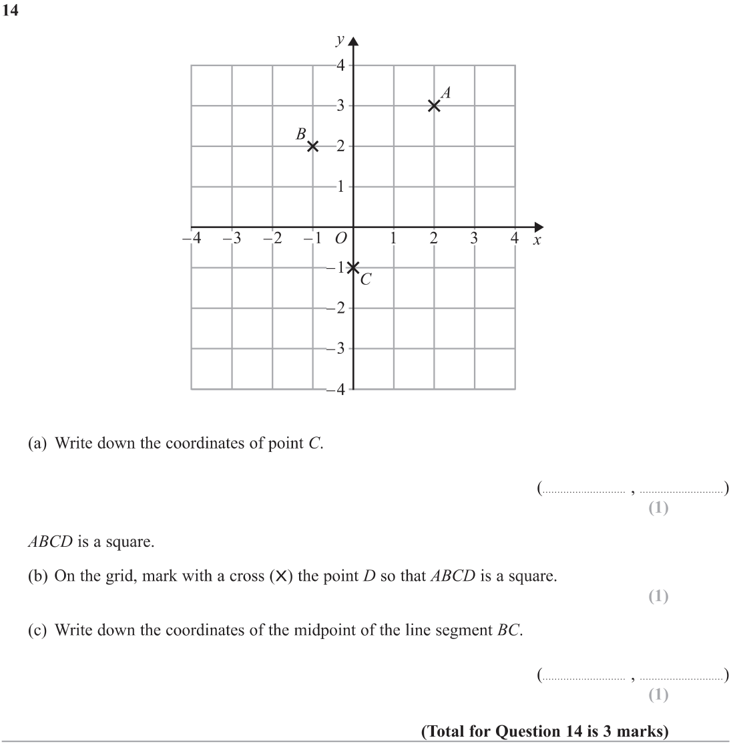

OCR Thursday 05 November 2020- Morning (Non-Calculator) Foundation Tier

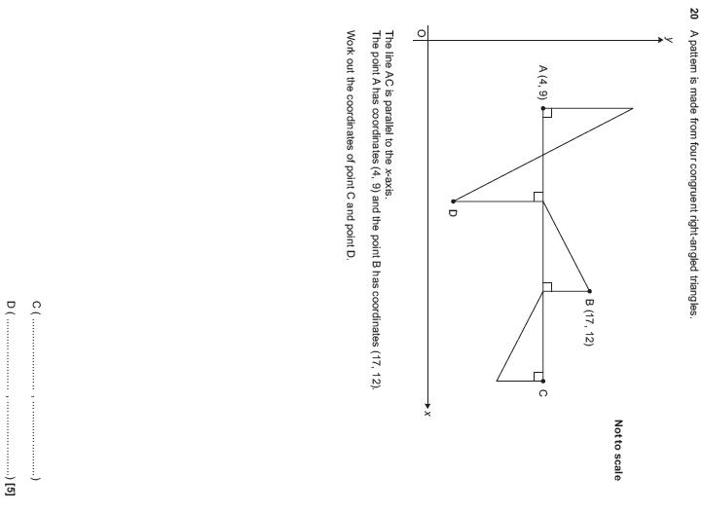

Pearson Edexcel – Sample Papers - Paper 3 (Calculator) Foundation Tier

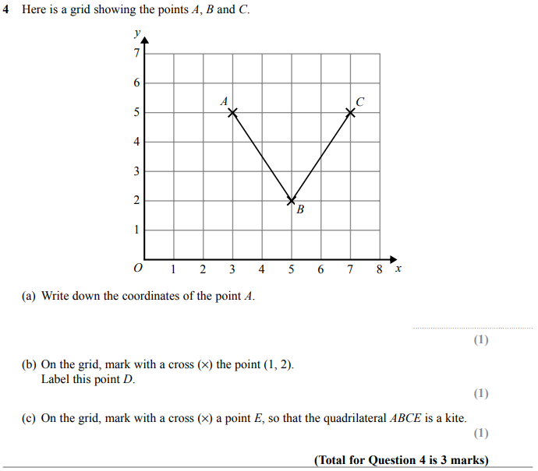

OCR Thursday 25 May 2017 – Morning (Calculator) Foundation Tier

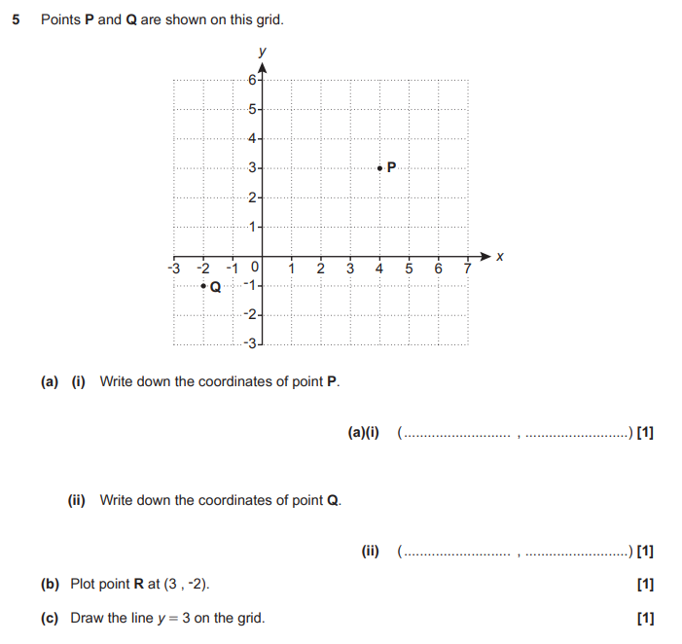

AQA Thursday 4 June 2020 – Morning (Calculator) Foundation Tier

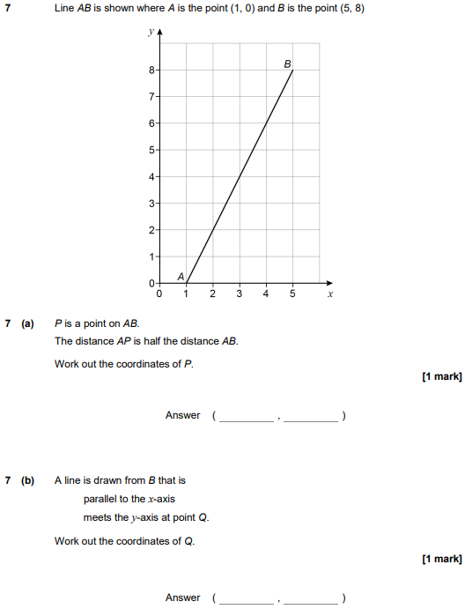

AQA Tuesday 21 May 2019 – Morning (Non-Calculator) Foundation Tier

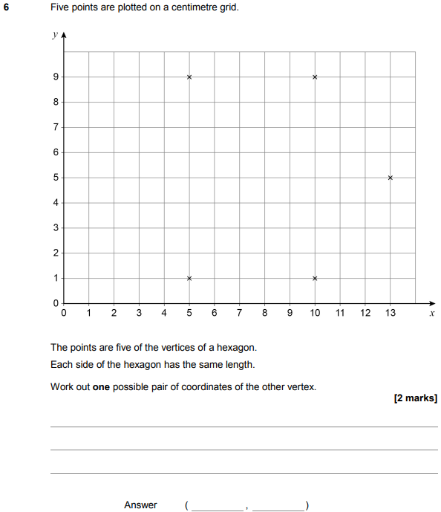

AQA Thursday 8 November 2018 – Morning (Calculator) Foundation Tier

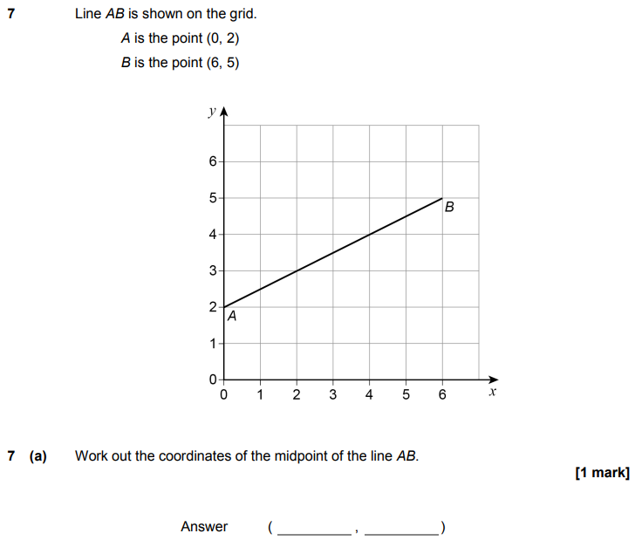
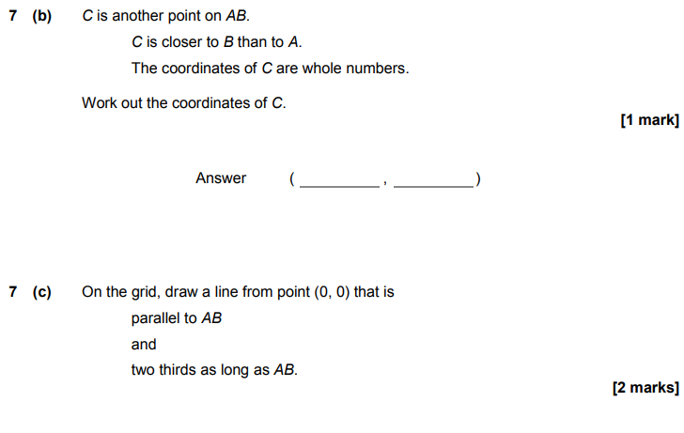

AQA Thursday 24 May 2018 – Morning (Non-Calculator) Foundation Tier

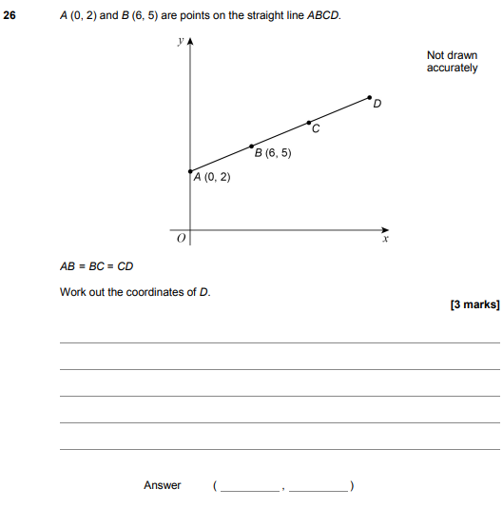

AQA Wednesday 8 November 2017 – Morning (Calculator) Foundation Tier

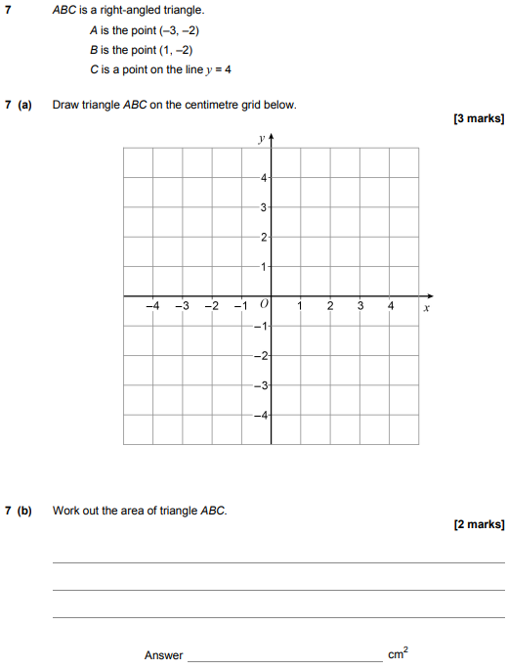

AQA Sample Paper 3– Morning (Calculator) Foundation Tier

